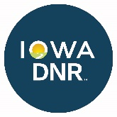**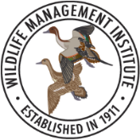JOB VACANCY ANNOUNCEMENT**

**FORESTRY SPECIALIST**

**Application Deadline:** The announcement is open until filled, and interviews are scheduled as applications are received. The successful applicant can expect to start within 2-4 weeks after a job offer.

**Position Duration:** 1 year. The position may be extended for additional years pending funding and job performance. If the position is extended, the candidate may be reassigned to another location in Iowa.

**Overview and Job Duties:** A position is available for a highly qualified individual to work in a joint capacity with Wildlife Management Institute (WMI) and the Iowa Department of Natural Resources (DNR) to promote healthy forest management. The successful applicant will help private landowners improve their woodlands for wildlife, recreation, wood products, and soil and water quality.

The successful applicant will serve as an employee of [Wildlife Management Institute](https://wildlifemanagement.institute/) (WMI) and receive supervision from WMI with daily instructions provided by the local DNR staff. Work priorities will be determined by local DNR District Foresters in conjunction with the DNR Private Lands Coordinator and the USDA-NRCS agreement funding the position. Training and support will be provided by the Iowa DNR, in particular the local District Foresters and the Private Lands Program Coordinator. Duties will include:

* Work closely with the local District Foresters and NRCS staff to identify opportunities for forest restoration and management.
* Work with private landowners to provide technical assistance for managing their properties, including conducting site visits and development of forest management plans.
* Develop Forest Management Plans and prescribed burning plans that meet NRCS standards and program requirements.
* Conduct outreach activities to promote forest management objectives within the designated working area.
* Work with private landowners to provide information and assistance with available conservation programs such as the Environmental Quality Incentives Program (EQIP), Conservation Stewardship Program (CSP), Resource Enhancement and Protection (REAP) and other federal, state, and local programs.
* Duties will also include contract development and coordination, site assessment and monitoring, and regular tracking and reporting of accomplishments.
* Attendance at relevant DNR and NRCS meetings and/or trainings will also be required.

**Required Knowledge, Skills and Abilities:**

* Superior communication (written and oral) skills. Must be comfortable both speaking in public and in engaging landowners on a one-to-one basis.
* Willingness to be a vocal advocate for young forests and active forest management to landowners and natural resource professionals.
* Ability to work independently.
* Knowledge of basic forest ecology and dynamics, especially related to the forest communities of Iowa.
* Knowledge of basic principles of wildlife management.
* Knowledge of relevant conservation programs, including Federal Farm Bill programs (CRP, EQIP and CSP), U.S. Fish & Wildlife Service Partners for Fish & Wildlife program, and other applicable federal, state, and local conservation programs.
* Ability to work long hours in the field and under adverse weather conditions.
* Familiarity with MS Word, MS Excel, and GIS.
* Valid driver’s license required with an acceptable driving record.

**Qualifications:**

Minimum - Bachelor’s Degree in Forestry or closely related field from an accredited academic institution. Preference will be given to candidates who have professional experience related to forest and/or forest wildlife management. Experience working with private landowners to develop conservation plans is also beneficial.

**Compensation:**

This salaried position pays $39,439/year ($20.50/hour equivalent). As a limited term employee of WMI, the incumbent will be expected to work no more than an average of 74 hours per two-week pay period. Work vehicles, office space, computers, etc. will be provided. The position will be eligible for WMI 401(k) retirement benefits and WMI will provide workers’ compensation, general liability protection, and professional liability protection and unemployment insurance benefits. The positions are eligible for health, dental, and vision insurance coverage. The positions are not eligible for vacation pay, sick leave, or disability benefits. WMI will withhold taxes including social security. The incumbent will be entitled to make voluntary contributions to their 401(k) retirement plan.

**Location:**

Fairfield, Iowa

The successful candidate will be stationed in Fairfield at the U.S. Department of Agriculture Service Center, and will work across several counties including portions of District 5, 6 (which currently has a District Forester vacancy), and 7.

**Private Lands Forestry Districts**

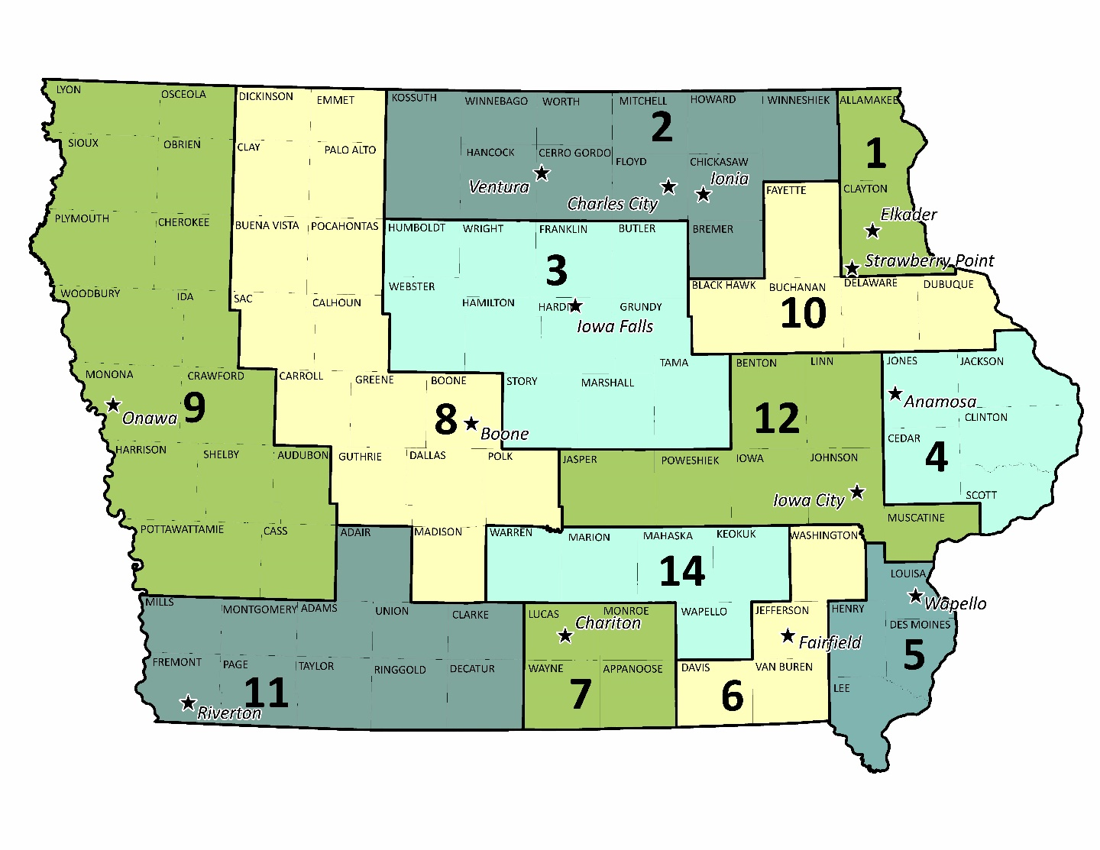

**To Apply:**

Please submit your resume, cover letter, and three professional references as one Word or pdf file. Send to [Katy.Fullin@dnr.iowa.gov](mailto:Katy.Fullin@dnr.iowa.gov). For questions about the duties, location, etc., contact Katy Fullin at Iowa DNR. For questions about WMI, contact Scot Williamson at [SWilliamson@wildlifemgt.org](mailto:SWilliamson@wildlifemgt.org).